### Alarm groups

In Alarm Groups you can define the looks of the DAP’s (see Figure 12‑7).

Under “duty alarm panels” you can set the rows and columns that you want to see if they are in alarm. You can choose up to 2 rows and up to 5 columns. Under “assigned alarm groups” you can define which alarm group you will see. Just click on a field and choose the specific alarm Group.

“This Station” defines the look and feel of the OWS. In default mode you have the same layout as a standard alarm page. You can also choose to only see a list of alarms or a list of alarms with the controls for silencing etc.

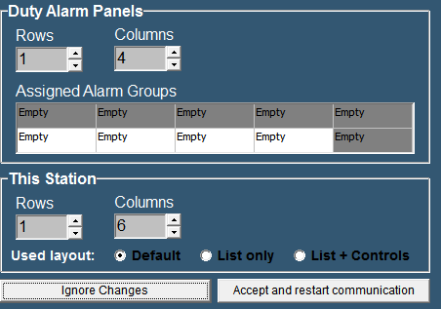

Figure 12‑7: Alarm Groups

*: after changing these settings choose “ accept changes” to activate the changes.*